Upgrade zboot
Before upgrading, please ensure that Ru is normally connected to PC through network cable, and that TFTP service is enabled on PC. for details, please refer to another document serial-rj45 upgrade mirror method.

Upgrade through network port
- Prepare the upgrade files (boot. Bin, boot. SCR, bootenv) and put them in the TFTP directory
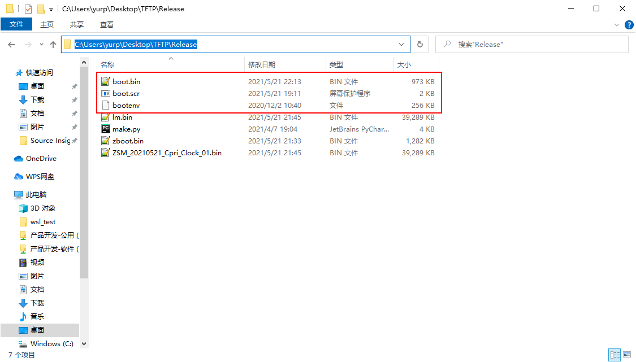
- Download boot.bin, boot.scr and bootenv to the current directory
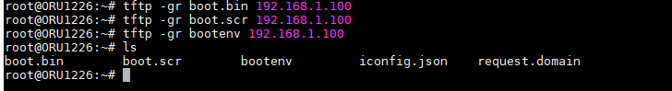

- Execute the following commands respectively：
flashcp -v boot.bin /dev/mtd0
flashcp -v bootenv /dev/mtd1
flashcp -v boot.scr /dev/mtd2
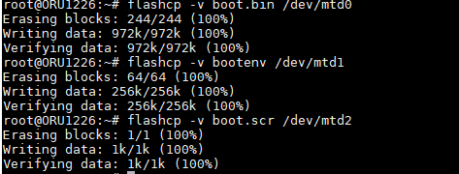

- After upgrading, remember that the image must be adapted to zboot, otherwise it cannot enter the system！

Upgrade through serial port
- Prepare the upgrade zboot. Bin and put it in the TFTP directory
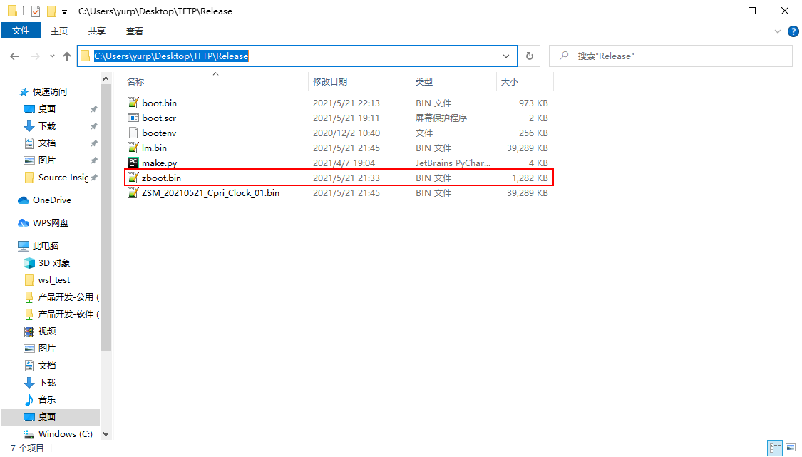
- In the countdown phase, press any key to interrupt the boot process and enter zboot
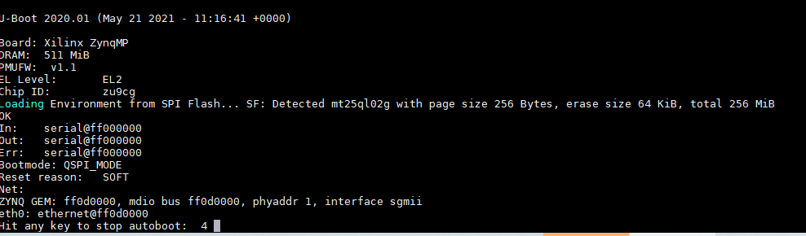
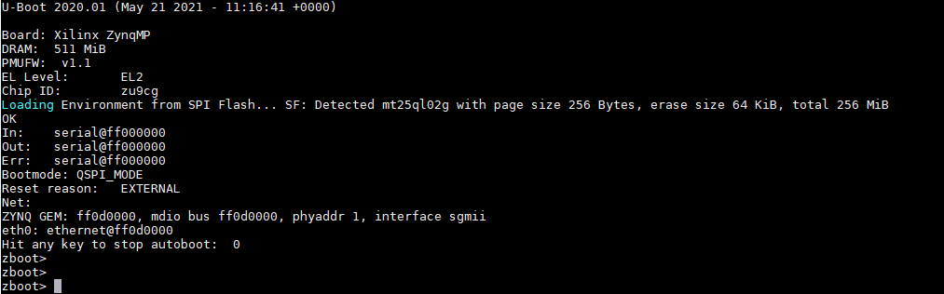

- Input command:
setenv ipaddr 192.168.1.101 && setenv serverip 192.168.1.100 && tftpboot 0x8000000 zboot.bin && sf probe 0 0 0 && sf erase 0x0 0x1c0000 && sf write 0x8000000 0x0 ${filesize} && echo OK!

Wait for execution to complete
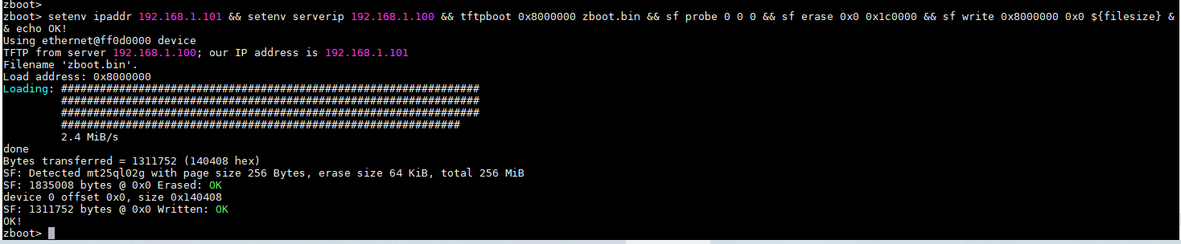

- After upgrading, remember that the image must be adapted to zboot, otherwise it cannot enter the system！

